**Dropbox widgets**

**Manual Installation**

1. Copy **com.temenos.widgets.dropbox** folder in your widgets folder (Ex: /{your project/templates })
2. Restart IDE.

**Auto-Installation**

1. Run IDE.
2. Make sure the “**Switch Monitor on/off**” is checked.
3. Download/ Copy the widget (**com.temenos.widgets.dropbox.zip**) to monitored folder.

(**Tools** menu, **Options**, **Auto-install** tab and set in “**Download Location**” the folder where you copied the widgets.) No need to restart IDE.

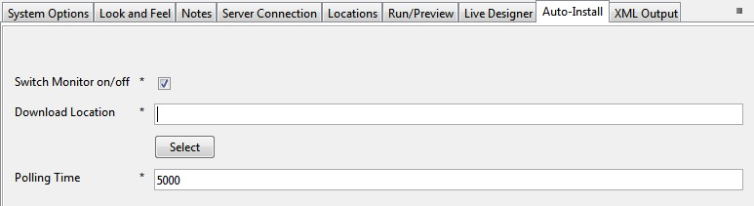

**How to use**

For all Dropbox widgets you have to set up the settings within “Dropbox Setup” (***App ID*** is common for all Dropbox widgets). See the image below.

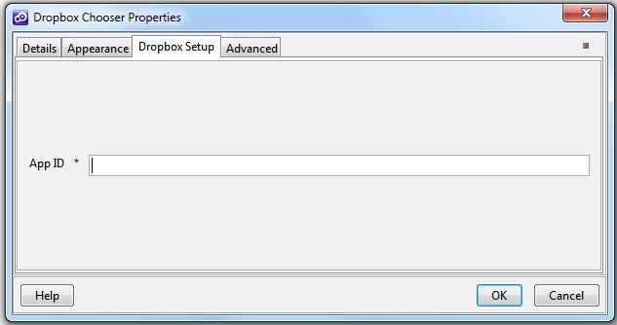

To obtain a valid app id you have to create a new application within your Dropbox developer account ([**https://www.dropbox.com/developers/apps**](https://www.dropbox.com/developers/apps%20)**).** A Developer Guide you can find here [**https://www.dropbox.com/developers/reference/devguide**](https://www.dropbox.com/developers/reference/devguide%20) **.**

1. **Dropbox Saver**

**Overview**

The **Dropbox Saver** button allow users to add files Dropbox. A user can download files of any size into their Dropbox, from a URL, making those files available on all their computers and devices as soon as the download completes. The Saver is a Drop-in component that works on web and mobile web.

1. You have to insert a new display Item of **Dropbox Saver** type in the **Presentation Editor**
2. Within Dropbox Setup tab you have to set up the widget settings.

* **App ID –** The Application ID created on your Dropbox account.
* **File URL** - URL of the file the Saver should add to the user's Dropbox. The Saver supports HTTP and HTTPS URIs.
* **Alternative File Name** - *optional* User-friendly name of the file that should be saved to the user's Dropbox can be included if desired. If not included, the filename is inferred from the `href`.

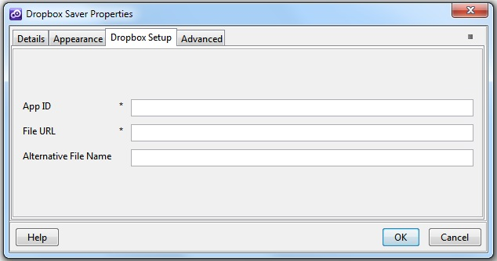

You could find more details on Dropbox website ([**https://www.dropbox.com/developers/dropins/saver**](https://www.dropbox.com/developers/dropins/saver%20))

1. **Dropbox Chooser**

**Overview**

The **Dropbox Chooser** button allow users to download an existing file from Dropbox account into their Computer or to use the url without having to worry about authentication or managing uploads and storage.

1. You will have to insert a new display Item of **Dropbox Chooser** type in the **Presentation Editor**
2. Within **Dropbox Setup** tab you have to set up the widget settings.

* **App ID** – The Application ID created on your Dropbox account.



You could find more details on Dropbox website ([**https://www.dropbox.com/developers/dropins/chooser/js**](https://www.dropbox.com/developers/dropins/chooser/js))